**BASH SCRIPTING**

1. Arithmetic Operators :

**CODE:**

#!/bin/bash

# read user input

echo Enter first variable \:

read a

echo Enter second variable \:

read b

echo Sum is\: $(($a + $b))

echo Difference is\: $(($a - $b))

echo Product is\: $(($a * $b))

echo Quotient is\: $(($a / $b))

echo Modulus is\: $(($a % $b))

echo We will create a new variable c and assign it with the value of the second variable

c=$b

echo new variable c = $c

echo using the \'==\' and \'!=\' operator

if [ $a -eq $b ]

then

echo a is equal to b

fi

if [ $a -ne $b ]

then

echo a is not equal to b

fi

**OUTPUT:**

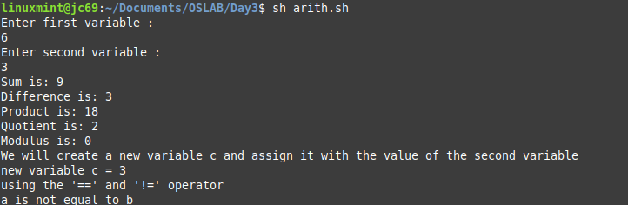

1. Relational Operators :

**CODE:**

#!/bin/bash

# read user input

echo Enter first variable \:

read a

echo Enter second variable \:

read b

echo using '-eq' \: checks if left and right operands are equal

if [ $a -eq $b ]

then

echo a is equal to b

fi

echo using '-ne' \: checks if left and right operands are unequal

if [ $a -ne $b ]

then

echo a is not equal to b

fi

echo using '-gt' \: checks if left operand is greater than right

if [ $a -gt $b ]

then

echo a is greater than b

fi

echo using '-lt' \: checks if left operand is less than right

if [ $a -lt $b ]

then

echo a is lesser than b

fi

echo using '-ge' \: checks if left operand is greater than or equal to then right

if [ $a -ge $b ]

then

echo a is greater than or equal to b

fi

echo using '-le' \: checks if left operand is less than or equal to then right

if [ $a -le $b ]

then

echo a is less than or equal to b

fi

**OUTPUT:**

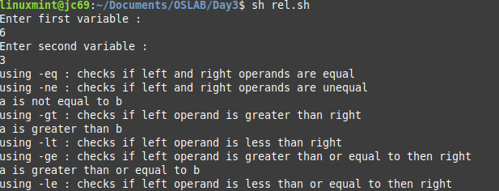

1. Boolean Operators :

**CODE:**

#!/bin/bash

# read user input

echo Enter first variable \:

read a

echo Enter second variable \:

read b

echo using logical negation \'!\'

if [ $a != $b ]

then

echo "$a != $b : a is not equal to b"

else

echo "$a != $b: a is equal to b"

fi

echo using logical OR \'-o\'

if [ $a -gt 90 -o $b -lt 50 ]

then

echo "$a -gt 90 -o $b -lt 50 : either a is greater than 90 OR b is less than 50"

else

echo "$a -gt 90 -o $b -lt 50: neither a is greater than 90 NOR b is less than 50"

fi

echo using logical AND \'-a\'

if [ $a -gt 90 -a $b -lt 50 ]

then

echo "$a -gt 90 -a $b -lt 50 : a is greater than 90 AND b is less than 50"

else

echo "$a -gt 90 -a $b -lt 50: either a is not greater than 90 OR b is not less than 50"

fi

**OUTPUT:**

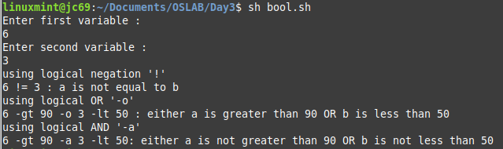

1. String Operators :

**CODE :**

#!/bin/bash

# read user input

echo Enter first variable \:

read a

echo Enter second variable \:

read b

if [ $a = $b ]

then

echo "$a = $b : $a is equal to $b"

else

echo "$a = $b: $a is not equal to $b"

fi

if [ $a != $b ]

then

echo "$a != $b : $a is not equal to $b"

else

echo "$a != $b: $a is equal to $b"

fi

echo Checking if length of strings is zero

if [ -z $a ]

then

echo "-z $a : string length is zero"

else

echo "-z $a : string length is not zero"

fi

echo Checking if length of strings is not zero

if [ -n $b ]

then

echo "-n $b : string length is not zero"

else

echo "-n $b : string length is zero"

fi

echo Checking if strings are non-empty

if [ $a ]

then

echo "$a : string is not empty"

else

echo "$a : string is empty"

fi

**OUTPUT:**

